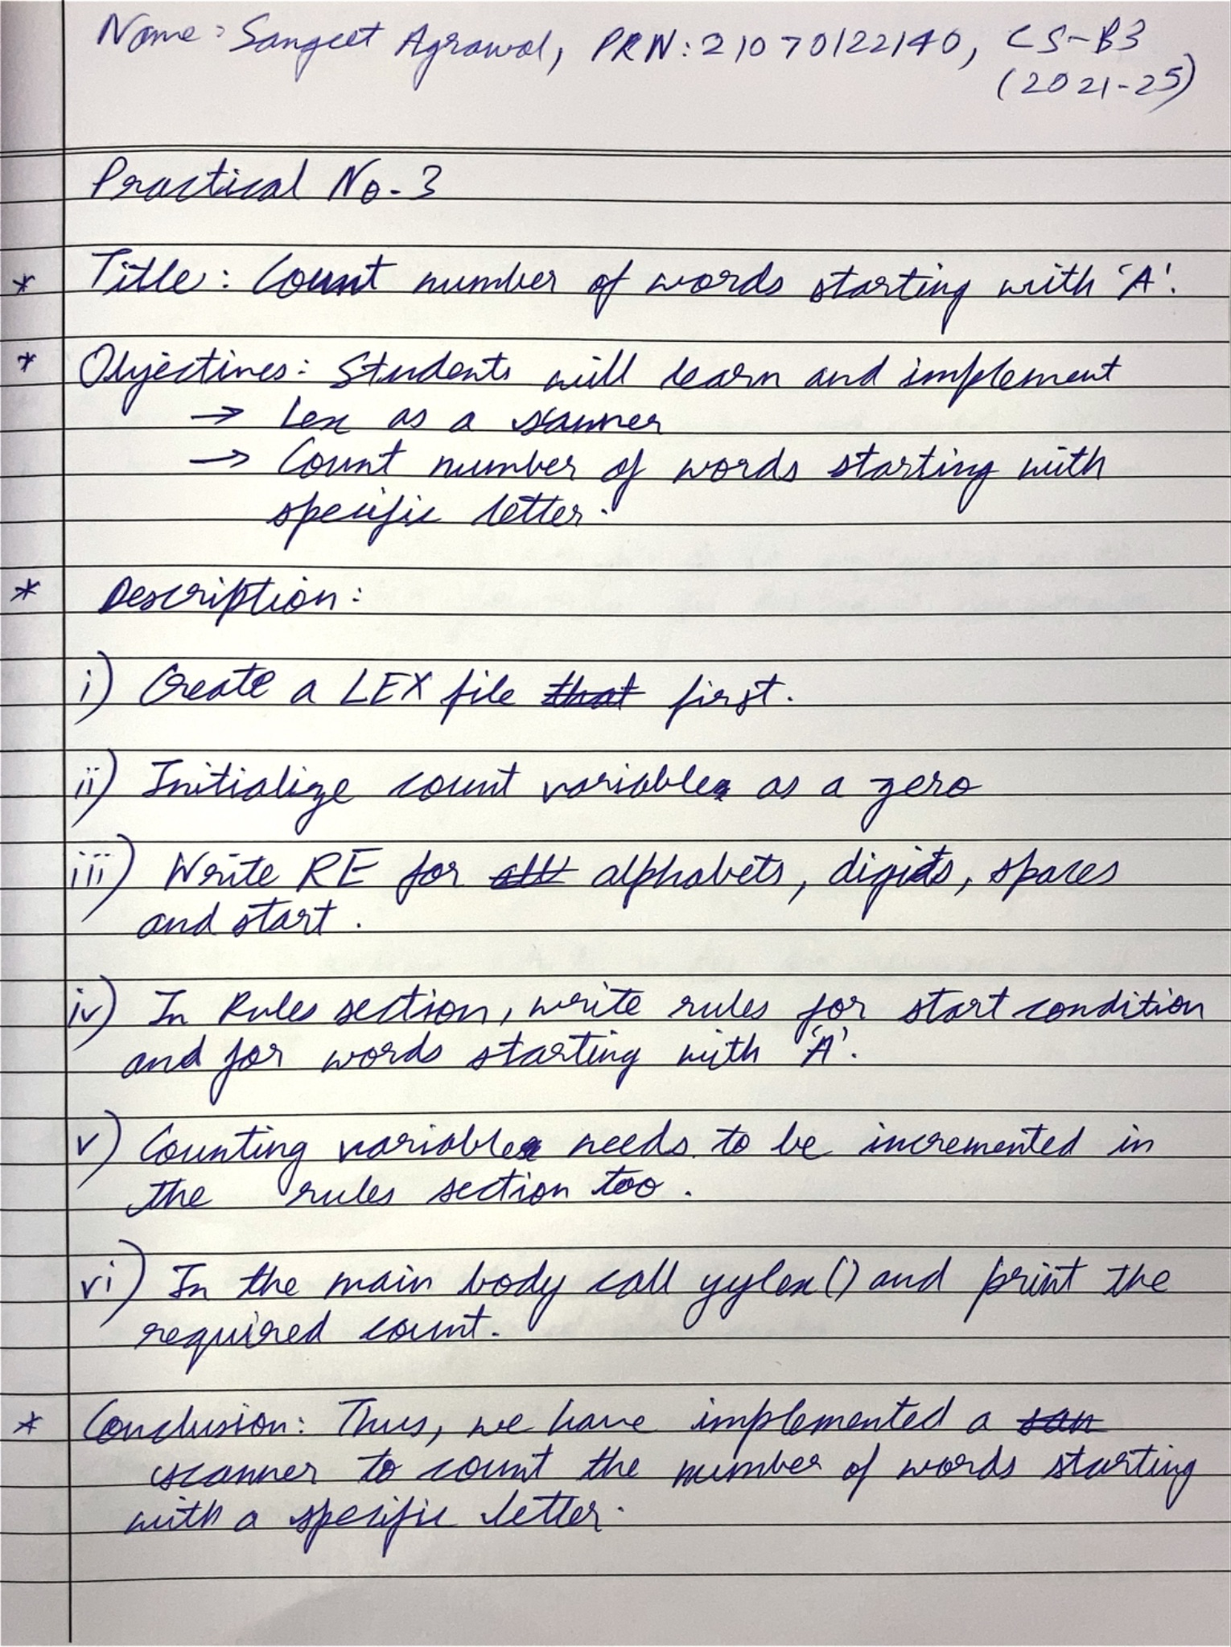

Code:

| %{ #include <stdio.h> int count = 0; %}  alpha [a-zA-Z] digit [0-9] space [ \t\n]  %% ^[aA][a-zA-Z0-9]* {   printf("%s\n", yytext);   count++;  }  {space}([aA][a-zA-Z0-9]*) {   printf("%s\n", yytext);   count++;  }  %%  int main() {  yylex();  printf("count = %d\n", count);  return 0; }  int yywrap() {  return 1; } |
| --- |

Output:

